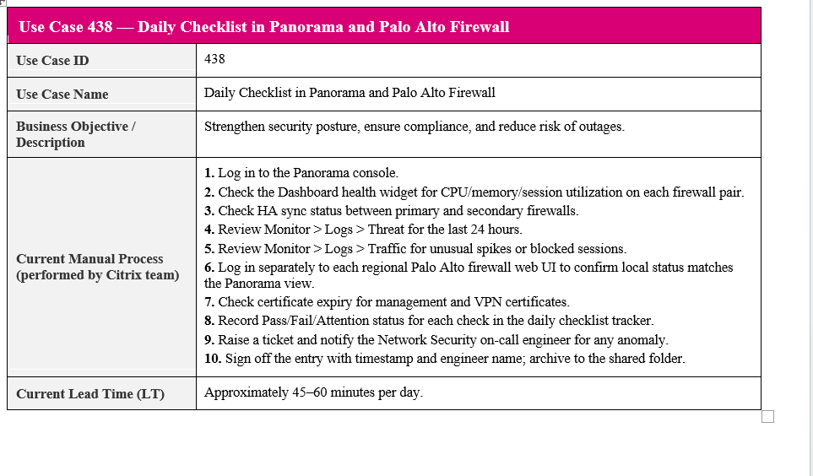
Panorama High Availability Status & Panorama CPU Utilization
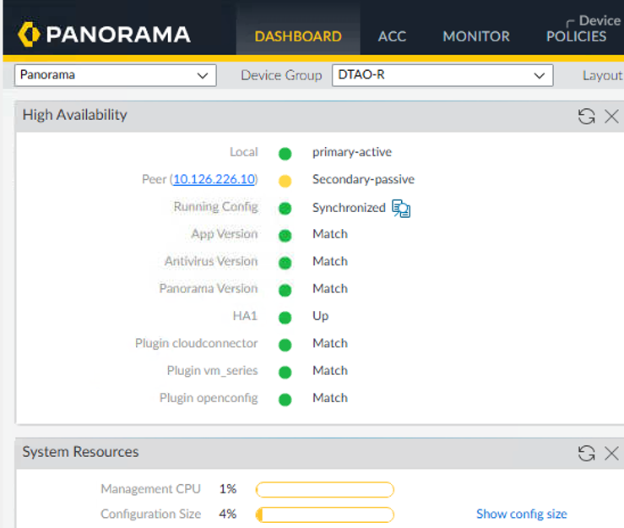
Panorama Device Summary:

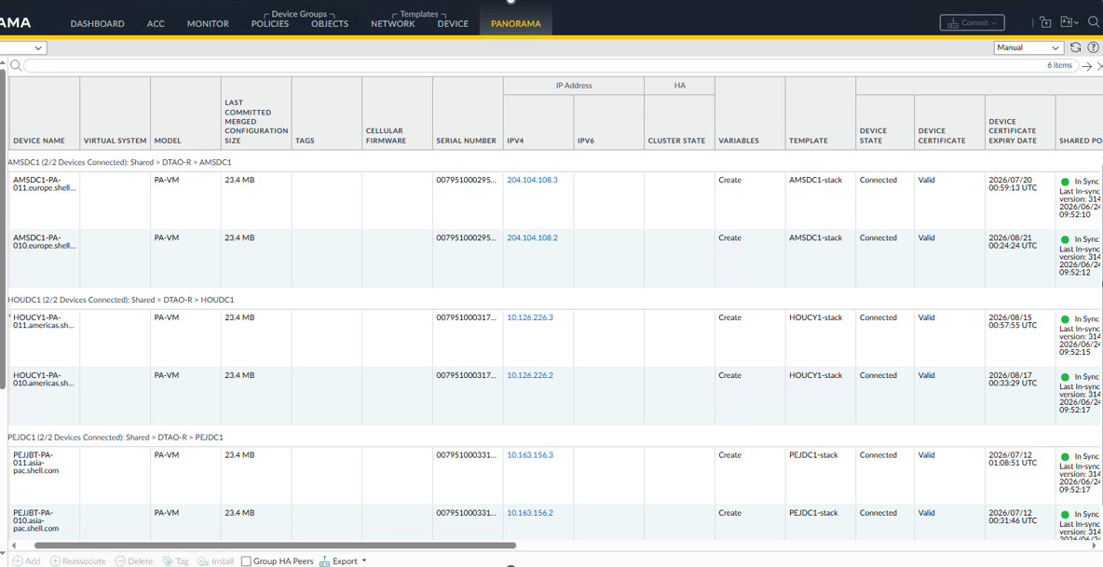

Panorama Health Summary – All Devices :

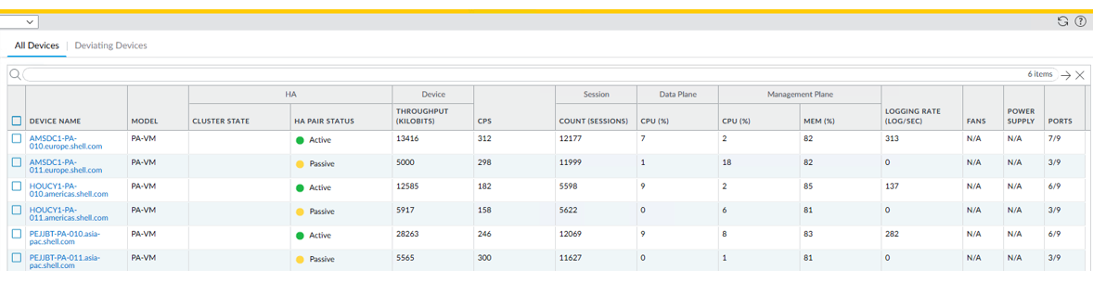
Panorama Health Summary – Deviating Devices:

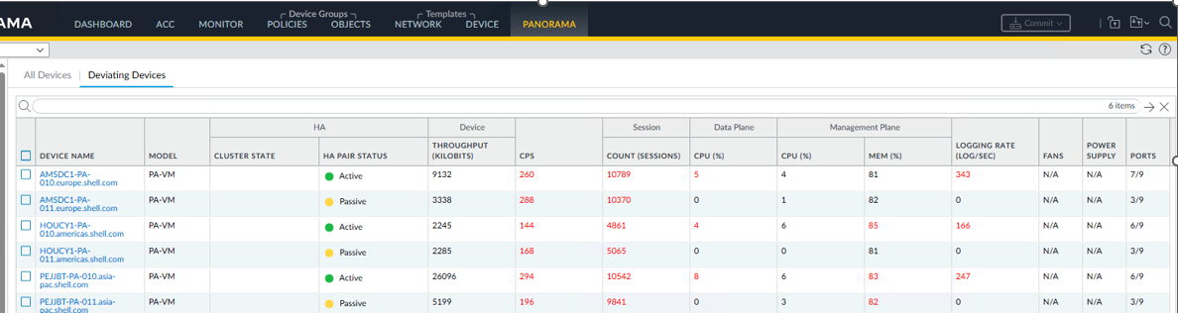

PA Firewall AMS:-

AMS:

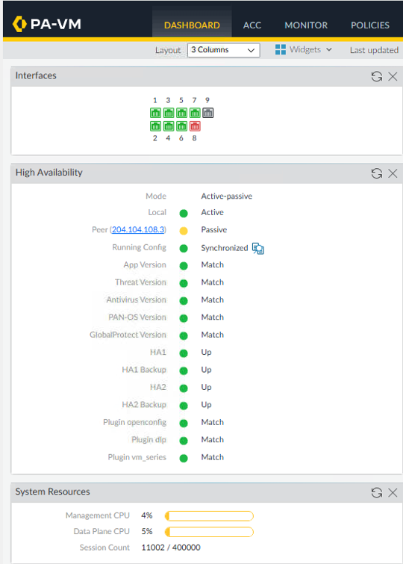

Terminal Server agent:

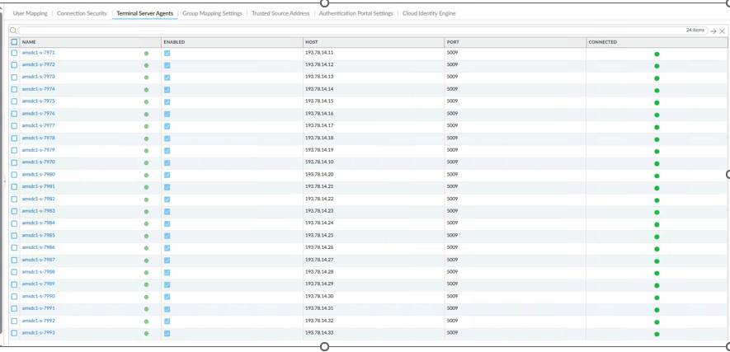

HOU:
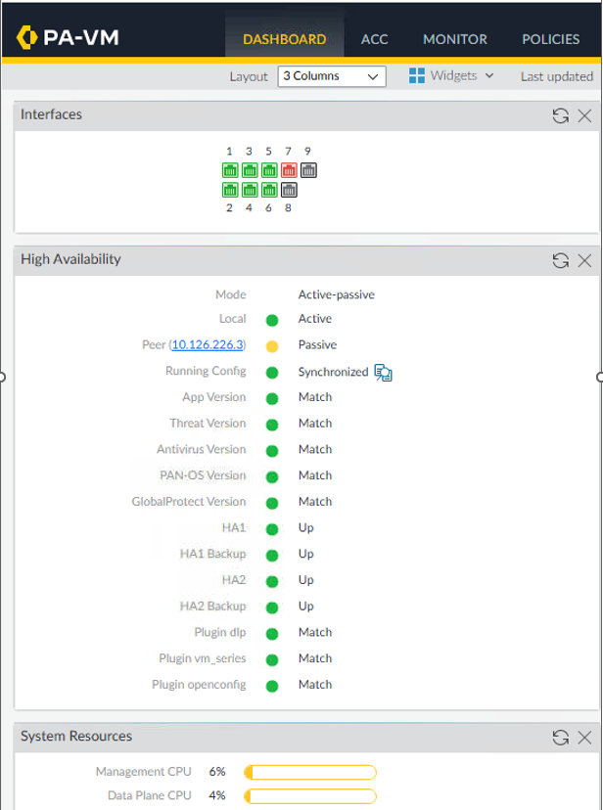

Terminal Server agent:

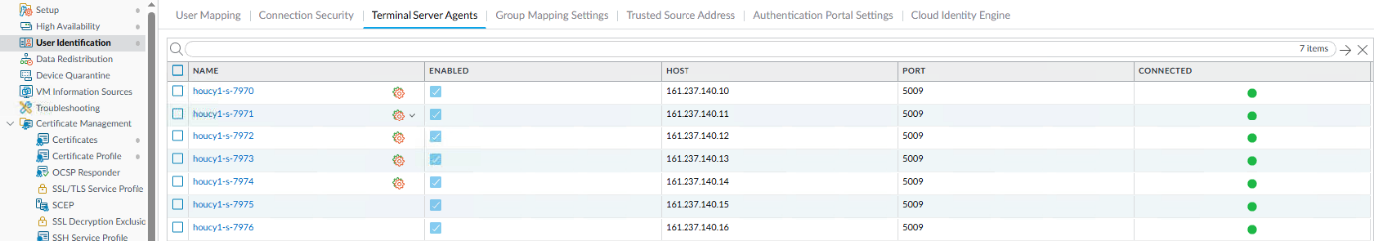

PEJ:

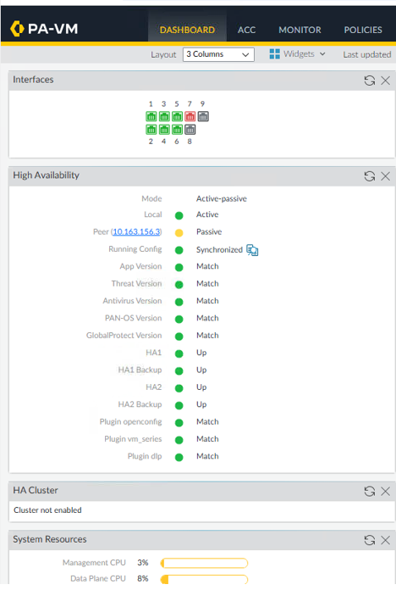

Terminal Server agent:

